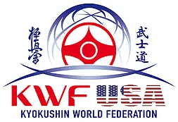
INTERNATIONAL AMERICAN
KARATE KYOKUSHIN CHAMPIONSHIPS 2019
KWF USA LITTLE LIONS CUP 2019

PARENTAL AGREEMENT TO PARTICIPATE
FOR PARTICIPANTS OF MINOR AGE (UNDER AGE 18 AT THE TIME OF REGISTRATION)

This is to certify that I, __[PARENT NAME]__________________, undersigned and acting as a parent / legal guardian with legal responsibility for this participant, ___________________ [NAME OF PARTICIPANT OF MINOR AGE] do consent, agree and provide permission for this participant of minor age to participate in the International American Karate Kyokushin Championships and Little Lions Cup on June 29, 2019, in Chicago Illinois, organized by the Kyokushin World Federation (KWF). I have authorized the Agreement Form above and I release and agree to indemnify and hold harmless the International American Karate Kyokushin Championships and Little Lions Cup Executive Committee and all other persons and organizations associated with this event from any and all liabilities incident to my minor child’s involvement or participation in these programs as provided above, EVEN IF ARISING FROM THEIR NEGLIGENCE, to the fullest extent permitted by law. I confirm that this participant of minor age has medical insurance for accidents, which covers any possible injury that may happen during the competition and I declare that I and my son/daughter/ pupil knows the rules of competition of this Championship.

Father/Mother/Guardian
Name:___________________________ Date:___________________________
Signature:________________________________
Emergency Phone Number: (_____)_________________

